**STRUCTURE FOR TODAY**

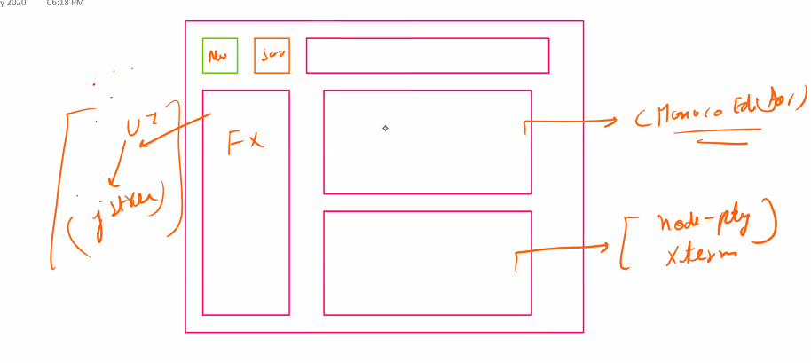

**SCROLL BAR CHANGER**

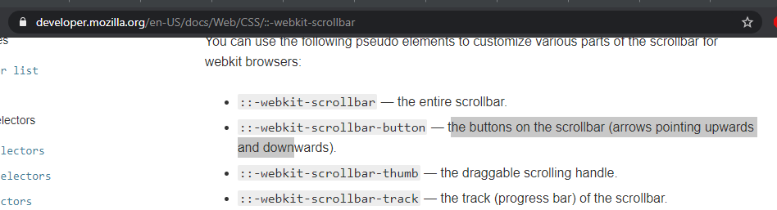

**BOX SHADOW**

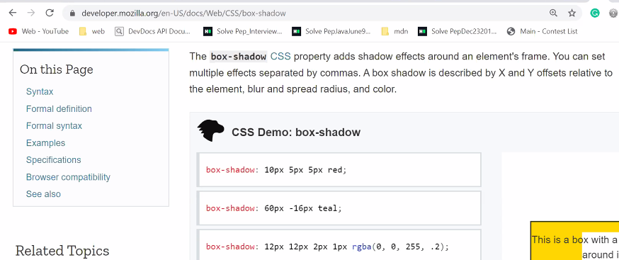

**MONACO**

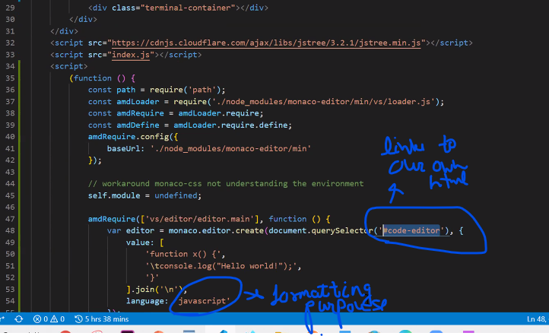

<https://github.com/microsoft/monaco-languages/tree/master/src>

[**https://github.com/microsoft/monaco-languages/tree/master/src**](https://github.com/microsoft/monaco-languages/tree/master/src)

**spoj**

**judge 0**